TITLE (Center, TNR 12pt., Bold)
Author’s name,
Author’s name
e-mail: name@unwe.bg ¹, e-mail: name@unwe.bg ²

Abstract

Your abstract should give readers a brief summary of your article. It should concisely describe the contents of your article and include key terms. It should be informative, accessible and not only indicate the general scope of the article but also state the main results obtained and conclusions drawn. The abstract should be complete in itself; it should not contain undefined abbreviations and no table numbers, figure numbers, references or equations should be referred to. It should be suitable for direct inclusion in abstracting services and should not exceed 100 words . Format: Font TNR 12 pt., Justified, Spacing 1,0).
Key words: up to 5 words. Format: TNR 12 pt., alignment in block, spacing 1,15.
JEL: For example, JEL: А10, F60 (see https://www.aeaweb.org/jel/guide/jel.php)

Introduction (TNR 12pt., bold, left centred)
Text - (TNR 12 pt., Justified, spacing 1,5). Introduction is a synthesized handout on the subject of the publication for the following sample questions: problem; existing solutions and degree of examination of the problem; limitations of the study; expected results of the author's study.
Main headings / Title (TNR 12pt., bold, left centred)
The volume of the articles is up to 12 pages (each page up to 1800 characters with spaces).
The articles must be structured in separate sections. They should consist of the following parts: introduction, main exposition, conclusion and references. It is recommended to follow the general organizational structure of the scientific publications – introduction, methods, results and discussion. The individual sections are distinguished by headings, with a clear indication of their hierarchy. Format: Font-Times New Roman 12pt, Normal, Justified.
Subtitle (TNR 12pt., bold)
All figures (diagrams, diagrams, Sketches, Web pages/screenshots and photographic images) should be numbered according to the order of citation in the text. The titles of the figures are placed beneath them.
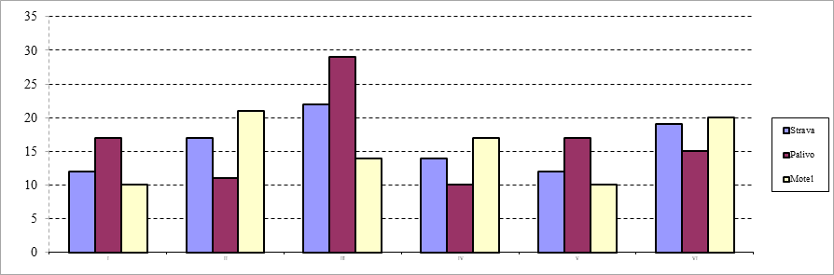
Source: Title (TNR 10pt., left, normal)
Figure 1: Title (TNR 11pt., centered, normal)
Tables should be numbered sequentially. Each table must have a title. The numbering and the titles of the tables should be placed above them. The necessary explanations shall be given below, by means of the corresponding symbols/signs.
Table 1: Table’s title (TNR 11pt., normal, centered)
TNRoman 10pt, single | TNRoman 10pt, single | TNRoman 10pt, single
TNRoman 10pt, single | TNRoman 10pt, single | TNRoman 10pt, single
TNRoman 10pt, single | TNRoman 10pt, single | TNRoman 10pt, single
TNRoman 10pt, single | TNRoman 10pt, single | TNRoman 10pt, single
Source: Title (TNR 10pt., Justified, Normal)
The equations should be placed in the middle. The formula numbers must be written in small brackets on the right side of the page! E.g:
(1)
Conclusion (TNR 12pt., bold, left centred)
Responds to the main research question, identifies opportunities for further research, originality and relevance of the results.
Sponsorship (TNR 12pt., bold, left centred)
The sources of funding (if anya) of the scientific study shall be provided.
References (TNR 12pt., bold, left centred)
A reference list is a complete list of all the sources used in the main text, abstract etc. This list includes information about the sources like the author, date of publication, title of the source and more. A Harvard reference list must be used:
- Be organised (without numbering) alphabetically by author, unless there is no author then it is ordered by the source title.
- If there are multiple works by the same author these are ordered by date, if the works are in the same year they are ordered alphabetically by the title and are allocated a letter (a,b,c etc) after the date
- Be ordered alphabetically, starting first with the Bulgarian sources.
- The Bulgarian sources are given first in their original way and then transliterated.
For example: Ерхард, Л., (1993). Благоденствие за всички, София, УИ “Стопанство”. (Erhard, L., 1993. Blagodenstvie za vsichki, Sofia: UI „Stopanstvo“).
- For more information on how to cite in Harvard style of referencing, please visit the following page: https://www.mendeley.com/guides/harvard-citation-guide
All references are cited in the text as follow:
(Shmit, 2020)
(Shmmit, 2020, p. 7) especially for text in quotes
(Shmit, 2020; Osborn, 2019)
(Shmit, 2020; Osborn, 2019, p. 7)
In cases as: According to Shmit (2020)
According to Shmit (2020, p. 7)
But for this citing the source is used earlier in the text as follow - (Schmidt, 2020)
For sources in Bulgarian:
(Иванов, 2019)
(Иванов, 2019, p. 7)
- For more information on how to cite in the text in Harvard style of referencing, please visit the following page: https://www.mendeley.com/guides/harvard-citation-guide

Academic title, scientific degree. Department/ Faculty, University, ORCID. Format: Footnote TNR 10pt., justified, spacing 1,15.
Academic title, scientific degree. Department/ Faculty, University, ORCID. Format: Footnote TNR 10pt., justified, spacing 1,15.
Notes (such as author’s comments)

